Software Design Document (SDD)
Lab assignment 01: GPIO

GPIO Driver — STM32F411RE

Module | GPIO Driver
Version | 1.0.0
Team | Sebastian Lizalde Herrera, Michelle Urbina Carlos, Melanie Picen Hernández
Date | 12/04/2026
Institution | CETYS Universidad

- Introduction

  - Purpose

This document describes the design and architecture of the GPIO (General Purpose Input/Output) driver module for the STM32F411RE microcontroller, based on the requirements defined in the corresponding Software Requirements Specification (SRS). It provides details on data structures, hardware register mappings, control flow, and the public API to guide implementation and testing of higher-level software modules that rely on GPIO functionality.

  - Scope

The GPIO driver is a low-level software component for the STM32F411RE embedded system. It abstracts the GPIO hardware registers of the STM32F411RE microcontroller and provides a clean, validated API for higher-level modules to initialize GPIO ports, configure pin modes, and perform atomic read, write, and toggle operations on individual GPIO pins. The driver supports ports A, B, C, D, E, and H, and covers pins 0 through 15 on each port.

  - Definitions and Acronyms

Term | Definition
GPIO | General Purpose Input/Output — configurable digital pins on a microcontroller.
STM32F411RE | ARM Cortex-M4 based microcontroller family by STMicroelectronics.
RCC | Reset and Clock Control — peripheral responsible for enabling clocks to GPIO ports.
AHB1 | Advanced High-performance Bus 1 — bus to which GPIO peripherals are connected on STM32F4.
MODER | GPIO Mode Register — configures each pin as input, output, alternate function, or analog.
ODR | Output Data Register — holds the output state of each GPIO pin.
IDR | Input Data Register — reflects the current logic level of each GPIO pin.
BSRR | Bit Set/Reset Register — allows atomic set and reset of individual GPIO output pins.
CMSIS | Cortex Microcontroller Software Interface Standard — vendor-independent hardware abstraction layer.
SRS | Software Requirements Specification — document defining the functional requirements for this module.
SDD | Software Design Document — this document.
API | Application Programming Interface — set of public functions exposed by the driver.
FR | Functional Requirement — a requirement that specifies a system behavior.
NFR | Non-Functional Requirement — a requirement that specifies a quality attribute of the system.

  - Requirements

All functional requirements specific to this module are defined and allocated in the Software Requirements Specification (SRS) for the GPIO driver module (Version 1.2, authored by Carlos Villarreal, CETYS Universidad). The SRS is the authoritative source for the behavioral requirements that this design document implements. The table below summarizes the traceability between each SRS functional requirement and the corresponding public API function implemented in this driver.

Req. ID | Function | Requirement Statement
FR-1 | gpio_init() | The system shall configure all GPIO ports to a default state.
FR-2 | gpio_initPort() | The system shall enable clocking for the specified port.
FR-3 | gpio_setPinMode() | The system shall allow configuration of pin direction and mode.
FR-4 | gpio_setPin() | The system shall drive the specified pin to a high state.
FR-5 | gpio_clearPin() | The system shall drive the specified pin to a low state.
FR-6 | gpio_togglePin() | The system shall invert the current state of the specified pin.
FR-7 | gpio_readPin() | The system shall return the digital state of the specified pin.

The SRS also defines the following non-functional requirements applicable to this driver: NFR-1 (lightweight and efficient implementation), NFR-2 (error handling for invalid port, pin, or mode inputs), and NFR-3 (real-time performance constraints). Additionally, the SRS references IEEE Std 830-1998 as the standard for requirements specification, and the hardware design is based on the STM32F411RE datasheet and the RM0383 STM32F411xC/E reference manual.

- System Architecture

2.1. High-Level Design

The GPIO driver follows a layered software architecture that separates application logic from low-level hardware access. The three layers are described below:

Layer | Description
Application Layer | Higher-level software modules that call the GPIO driver public API functions to control hardware behavior without direct register access.
GPIO Driver Layer | Implements the public API declared in GPIO_stm32f4.h. Validates all input parameters, enables peripheral clocks via RCC, and performs direct read/write operations on GPIO hardware registers through the GPIO_RegDef_t and RCC_RegDef_t register map structures.
Hardware Layer | Actual STM32F4 microcontroller GPIO peripheral registers (MODER, ODR, IDR, BSRR, etc.) mapped at fixed memory addresses via the AHB1 peripheral bus.

2.2. Module Interfaces

The GPIO driver exposes its functionality exclusively through the public header file GPIO_stm32f4.h. The module has the following interface characteristics:
- Public API: All user-callable functions are declared in GPIO_stm32f4.h. These include gpio_init, gpio_initPort, gpio_setPinMode, gpio_setPin, gpio_clearPin, gpio_togglePin, and gpio_readPin.
- Internal implementation: All function bodies and internal static data structures (gpio_ports[], gpio_clk_masks[]) are defined in GPIO_stm32f4.c and are not visible to external modules.
- Dependencies: The driver depends only on the C standard library header <stdint.h> for fixed-width integer types. No HAL or external libraries are used; all hardware access is performed through direct register manipulation using the GPIO_RegDef_t and RCC_RegDef_t structures.
- Hardware dependencies: STM32F4 GPIO peripheral registers mapped at AHB1PERIPH_BASE + port-specific offsets, and the RCC AHB1ENR register for clock gating.

- Detailed Design

3.1. Class Diagram

The figure below represents the static structure of the GPIO driver, showing the two register-map structures, the enumerations for port, mode, and status, and their relationships to the three-layer architecture. Public members are marked with a filled circle (●) and private/internal members with an open circle (○).
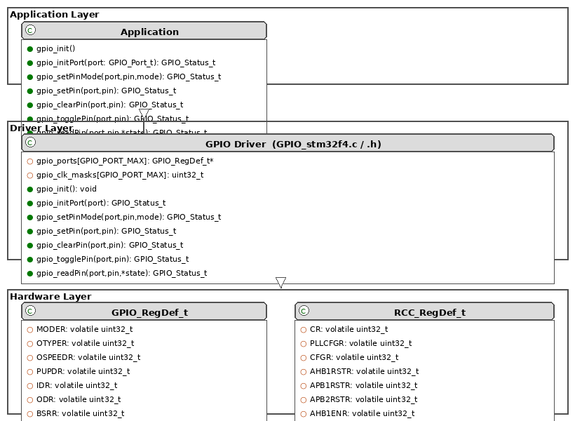
Figure 1. Class Diagram — GPIO Driver

3.2. Module Behavior

The following diagrams describe the behavioral design of each public function. Each function is covered by a sequence diagram (interaction between caller and driver) and an activity diagram (internal control flow including input validation).

gpio_init — Global Initialization (FR-1)

The function enables clocks for all six GPIO ports in a single register write and resets pin modes for ports B through H. Port A is excluded from the MODER reset to preserve the SWD debug interface.
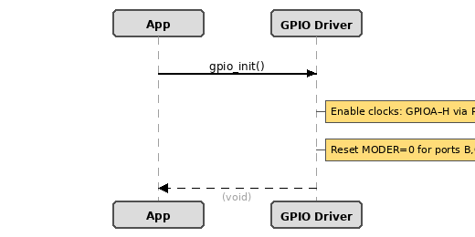
Figure 2. Sequence Diagram — gpio_init
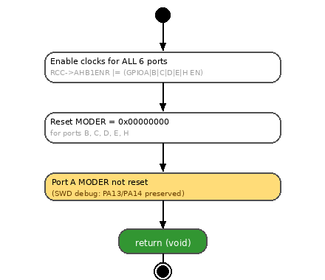
Figure 3. Activity Diagram — gpio_init

gpio_initPort — Per-Port Clock Enable (FR-2)

The function validates the port parameter before enabling its peripheral clock selectively via the RCC AHB1ENR register. Returns GPIO_ERR_PORT immediately if the port is out of range.
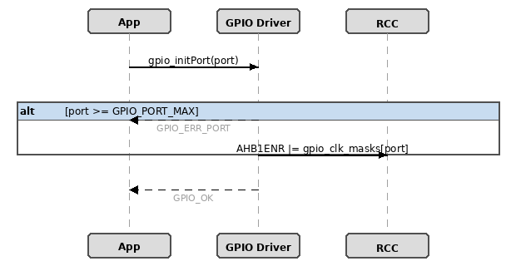
Figure 4. Sequence Diagram — gpio_initPort
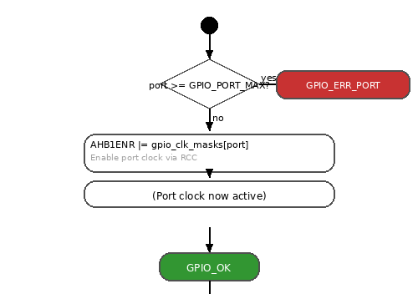
Figure 5. Activity Diagram — gpio_initPort

gpio_setPinMode — Pin Mode Configuration (FR-3)

The function validates three parameters (port, pin, and mode) before performing a read-modify-write on the MODER register. The 2-bit field for the target pin is cleared first, then the new mode value is OR'd in, leaving all other pin configurations intact.
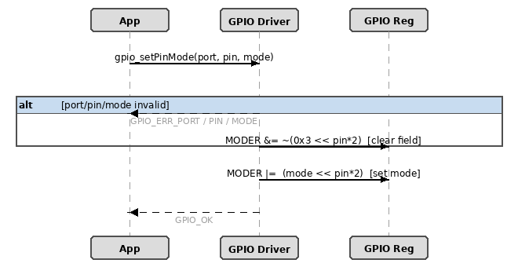
Figure 6. Sequence Diagram — gpio_setPinMode
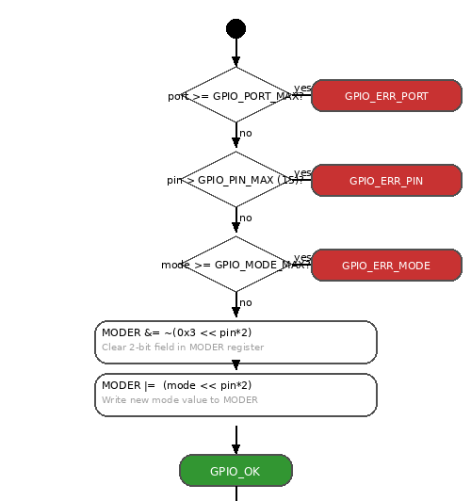
Figure 7. Activity Diagram — gpio_setPinMode
gpio_setPin / gpio_clearPin — Atomic Output Control (FR-4, FR-5)

Both functions write to the BSRR register which guarantees atomic operation. gpio_setPin writes to the set-side (bits [15:0]) and gpio_clearPin writes to the reset-side (bits [31:16]), each requiring only a single write with no prior read.
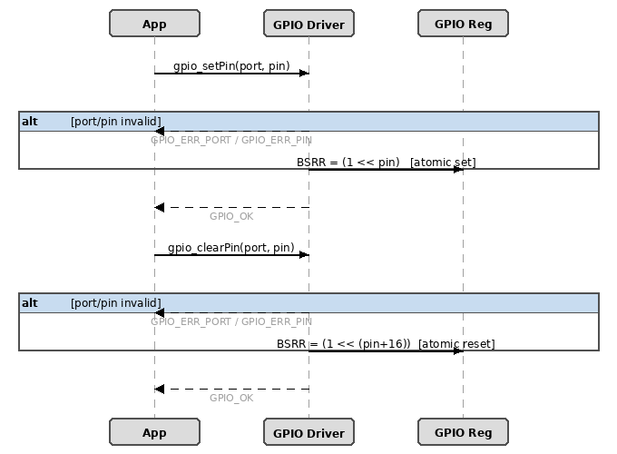
Figure 8. Sequence Diagram — gpio_setPin / gpio_clearPin
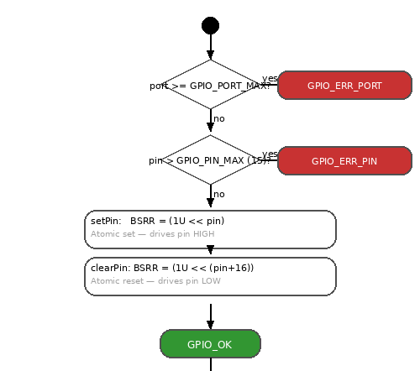
Figure 9. Activity Diagram — gpio_setPin / gpio_clearPin

gpio_togglePin — XOR Toggle (FR-6)

The function reads the current ODR value and XORs bit pin to invert that pin's output state. This is a non-atomic read-modify-write operation on ODR; the caller must ensure mutual exclusion if concurrent access is possible.
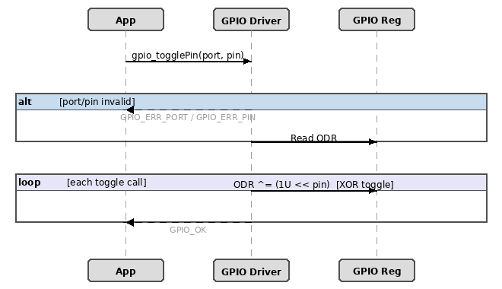
Figure 10. Sequence Diagram — gpio_togglePin
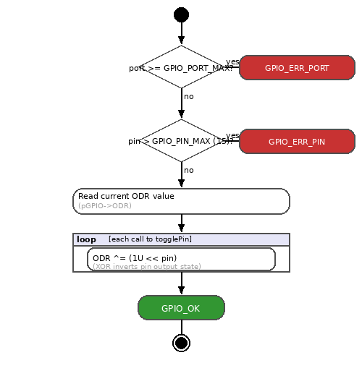
Figure 11. Activity Diagram — gpio_togglePin

gpio_readPin — IDR Read (FR-7)

The function validates three conditions (port, pin, and null pointer) before reading the IDR register. It extracts the single bit for the target pin and stores the result (0 or 1) at the caller-provided address.
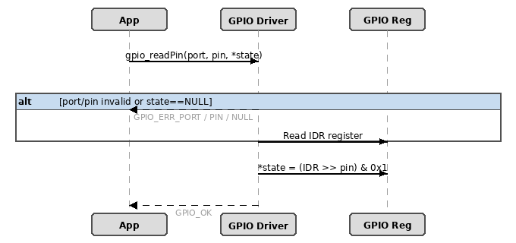
Figure 12. Sequence Diagram — gpio_readPin
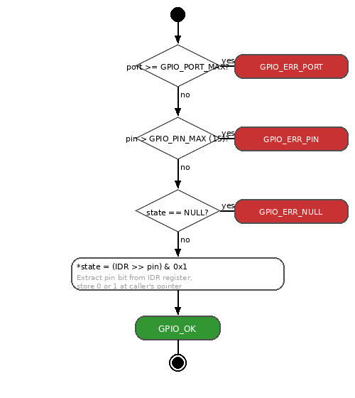
Figure 13. Activity Diagram — gpio_readPin

Driver State Machine

The state diagram below describes the overall lifecycle of the GPIO driver from system reset through initialization to normal application operation.
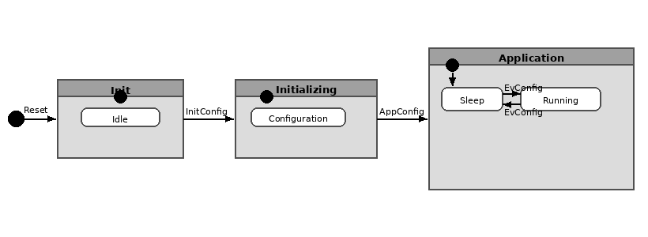
Figure 14. State Diagram — GPIO Driver Lifecycle

  - GPIO Driver

The GPIO driver for the STM32F411RE is implemented in two files: GPIO_stm32f4.h (public declarations and hardware definitions) and GPIO_stm32f4.c (implementation). The driver operates entirely through direct hardware register access — no HAL or vendor middleware is used.

Internal Data Structures

Two static constant arrays are defined in GPIO_stm32f4.c and are not visible to external modules:
- gpio_ports[GPIO_PORT_MAX]: An array of pointers to GPIO_RegDef_t mapping each GPIO_Port_t enum value to its corresponding memory-mapped register block (GPIOA through GPIOH). All functions resolve a port by indexing this array rather than using conditional branching.
- gpio_clk_masks[GPIO_PORT_MAX]: An array of uint32_t values, each holding the RCC_AHB1ENR bit mask required to enable the clock for the corresponding GPIO port. Used by both gpio_init and gpio_initPort.

Initialization Flow

- gpio_init (FR-1): Enables peripheral clocks for all six ports simultaneously by OR-ing all RCC_AHB1ENR_GPIOxEN bits into RCC->AHB1ENR in a single write. Resets MODER to 0x00000000 for ports B, C, D, E, and H. Port A's MODER is intentionally not reset to preserve SWD debug interface pins PA13 and PA14.
- gpio_initPort (FR-2): Enables the clock for a single user-specified port by applying the corresponding bit mask from gpio_clk_masks[]. Validates the port parameter before accessing the array.

Pin Mode Configuration

gpio_setPinMode (FR-3) configures an individual pin mode in MODER. Each pin occupies a 2-bit field at bit position (pin × 2). The function first clears the field using MODER &= ~(0x3 << pin*2), then writes the new mode using MODER |= mode << pin*2. Three parameters are validated: port, pin, and mode.

Output Control — Set, Clear, Toggle

- gpio_setPin (FR-4): Writes 1 to bit position pin in BSRR bits [15:0]. Atomic — no intermediate glitch state.
- gpio_clearPin (FR-5): Writes 1 to bit position (pin+16) in BSRR bits [31:16]. Also atomic.
- gpio_togglePin (FR-6): XORs bit pin in ODR. Non-atomic read-modify-write — caller must ensure mutual exclusion under concurrent access.

Pin Read

gpio_readPin (FR-7) reads the IDR register, shifts right by pin positions, and masks with 0x1 to extract the target bit, storing the result at the caller's pointer. A null-pointer check is performed before dereferencing. The function works for both input and output configured pins since IDR always reflects the actual pin voltage.

- Application Programming Interfaces

4.1. Data Types and Macros

Register-Map Structures

GPIO_RegDef_t: Maps the memory layout of a single GPIO port's hardware registers. Each field is declared volatile to prevent compiler optimization of hardware register accesses.
Member | Type | Notes / Definition
MODER | volatile uint32_t | Offset 0x00 — configures each pin: input(00), output(01), alt-fn(10), analog(11).
OTYPER | volatile uint32_t | Offset 0x04 — output type: push-pull(0) or open-drain(1).
OSPEEDR | volatile uint32_t | Offset 0x08 — controls slew rate / output speed per pin.
PUPDR | volatile uint32_t | Offset 0x0C — configures pull-up(01) or pull-down(10) resistors.
IDR | volatile uint32_t | Offset 0x10 — read-only; reflects the current logic level on each pin.
ODR | volatile uint32_t | Offset 0x14 — read/write; controls output state of each pin.
BSRR | volatile uint32_t | Offset 0x18 — write-only; bits[15:0] set pins, bits[31:16] reset pins atomically.
LCKR | volatile uint32_t | Offset 0x1C — locks pin configuration until next reset.
AFR[2] | volatile uint32_t | Offset 0x20 — alternate function: AFR[0] for pins 0–7, AFR[1] for pins 8–15.

RCC_RegDef_t: Maps a subset of the STM32F4 RCC peripheral registers up to and including AHB1ENR, the only RCC register used by this driver.

Member | Type | Notes / Definition
CR | volatile uint32_t | Clock control register.
PLLCFGR | volatile uint32_t | PLL configuration register.
CFGR | volatile uint32_t | Clock configuration register.
CIR | volatile uint32_t | Clock interrupt register.
AHB1RSTR | volatile uint32_t | AHB1 peripheral reset register.
AHB2RSTR | volatile uint32_t | AHB2 peripheral reset register.
RESERVED0[2] | volatile uint32_t | Reserved — must not be accessed.
APB1RSTR | volatile uint32_t | APB1 peripheral reset register.
APB2RSTR | volatile uint32_t | APB2 peripheral reset register.
RESERVED1[2] | volatile uint32_t | Reserved — must not be accessed.
AHB1ENR | volatile uint32_t | AHB1 peripheral clock enable — bit 0 = GPIOA, bit 1 = GPIOB, …, bit 7 = GPIOH.

Enumerations

GPIO_Port_t: Identifies each supported GPIO port. GPIO_PORT_MAX is a sentinel value used for bounds validation only.

Enumerator | Value | Definition
GPIO_PORT_A | 0 | Port A
GPIO_PORT_B | 1 | Port B
GPIO_PORT_C | 2 | Port C
GPIO_PORT_D | 3 | Port D
GPIO_PORT_E | 4 | Port E
GPIO_PORT_H | 5 | Port H
GPIO_PORT_MAX | 6 | Sentinel — boundary validation; not a valid port.

GPIO_Mode_t: Specifies the operating mode for a GPIO pin. Values correspond directly to the 2-bit encoding in the MODER register.

Enumerator | Value | Definition
GPIO_MODE_INPUT | 0x00 | Digital input — pin samples the external voltage level.
GPIO_MODE_OUTPUT | 0x01 | Digital output — pin is driven by ODR or BSRR.
GPIO_MODE_ALTFN | 0x02 | Alternate function — pin controlled by a peripheral (UART, SPI, I2C, etc.).
GPIO_MODE_ANALOG | 0x03 | Analog mode — connected to ADC/DAC; digital buffers disabled.
GPIO_MODE_MAX | 4 | Sentinel — boundary validation; not a valid mode.

Preprocessor Macros

Macro | Value | Definition
PERIPH_BASE | 0x40000000UL | Base address of all STM32F4 peripherals.
AHB1PERIPH_BASE | PERIPH_BASE + 0x00020000UL | Base address of the AHB1 peripheral bus.
GPIOA_BASE | AHB1PERIPH_BASE + 0x0000UL | Base address of GPIO port A registers.
GPIOB_BASE | AHB1PERIPH_BASE + 0x0400UL | Base address of GPIO port B registers.
GPIOC_BASE | AHB1PERIPH_BASE + 0x0800UL | Base address of GPIO port C registers.
GPIOD_BASE | AHB1PERIPH_BASE + 0x0C00UL | Base address of GPIO port D registers.
GPIOE_BASE | AHB1PERIPH_BASE + 0x1000UL | Base address of GPIO port E registers.
GPIOH_BASE | AHB1PERIPH_BASE + 0x1C00UL | Base address of GPIO port H registers.
RCC_BASE | AHB1PERIPH_BASE + 0x3800UL | Base address of the RCC peripheral registers.
GPIOA … GPIOH | (GPIO_RegDef_t *) GPIOx_BASE | Typed pointer macros for direct register access per port.
RCC | (RCC_RegDef_t *) RCC_BASE | Typed pointer macro for RCC direct register access.
RCC_AHB1ENR_GPIOAEN | (1U << 0) | Bit mask to enable GPIOA clock in RCC->AHB1ENR.
RCC_AHB1ENR_GPIOBEN | (1U << 1) | Bit mask to enable GPIOB clock in RCC->AHB1ENR.
RCC_AHB1ENR_GPIOCEN | (1U << 2) | Bit mask to enable GPIOC clock in RCC->AHB1ENR.
RCC_AHB1ENR_GPIODEN | (1U << 3) | Bit mask to enable GPIOD clock in RCC->AHB1ENR.
RCC_AHB1ENR_GPIOEEN | (1U << 4) | Bit mask to enable GPIOE clock in RCC->AHB1ENR.
RCC_AHB1ENR_GPIOHEN | (1U << 7) | Bit mask to enable GPIOH clock in RCC->AHB1ENR.
GPIO_PIN_MAX | 15U | Maximum valid pin number (inclusive). Pins 0–15.

4.2. Error Codes

All public GPIO API functions (except gpio_init, which returns void) have a return type of GPIO_Status_t. Error codes are listed below:

Code | Value | Definition
GPIO_OK | 0 | Operation completed successfully.
GPIO_ERR_PORT | -1 | The port parameter is invalid (>= GPIO_PORT_MAX).
GPIO_ERR_PIN | -2 | The pin parameter is invalid (> GPIO_PIN_MAX = 15).
GPIO_ERR_MODE | -3 | The mode parameter is invalid (>= GPIO_MODE_MAX).
GPIO_ERR_NULL | -4 | A required pointer is NULL (applies to gpio_readPin state pointer).

4.3. Function Definitions

gpio_init

Function Name | gpio_init
Syntax | void gpio_init(void)
Parameters (in) | None
Parameters (inout) | None
Parameters (out) | None
Return value | void
Description | Enables peripheral clocks for all six supported GPIO ports (A, B, C, D, E, H) simultaneously by setting the corresponding bits in RCC->AHB1ENR. Additionally resets the MODER register to 0x00000000 for ports B, C, D, E, and H. Port A's MODER is intentionally not reset to preserve SWD debug interface on PA13 and PA14.
Constraints | No parameter validation performed. Port A MODER is not reset. Must be called before any other GPIO driver function if all ports are to be initialized at once.
Available via | GPIO_stm32f4.h

gpio_initPort

Function Name | gpio_initPort
Syntax | GPIO_Status_t gpio_initPort(GPIO_Port_t port)
Parameters (in) | port | GPIO_Port_t — selects the GPIO port whose clock will be enabled (GPIO_PORT_A through GPIO_PORT_H).
Parameters (inout) | None  —
Parameters (out) | None  —
Return value | GPIO_Status_t | GPIO_OK on success. GPIO_ERR_PORT if port >= GPIO_PORT_MAX.
Description | Enables the peripheral clock for a single GPIO port using the gpio_clk_masks[] lookup table to set the correct bit in RCC->AHB1ENR. Validates the port parameter before any hardware access.
Constraints | Does not reset or configure pin modes; only enables the clock. The caller must call gpio_setPinMode separately to configure individual pins.
Available via | GPIO_stm32f4.h

gpio_setPinMode

Function Name | gpio_setPinMode
Syntax | GPIO_Status_t gpio_setPinMode(GPIO_Port_t port, uint8_t pin, GPIO_Mode_t mode)
Parameters (in) | port | GPIO_Port_t — target GPIO port.
Parameters (in) | pin | uint8_t — target pin number (0–15).
Parameters (in) | mode | GPIO_Mode_t — desired pin mode (INPUT, OUTPUT, ALTFN, ANALOG).
Parameters (inout) | None | —
Parameters (out) | None | —
Return value | GPIO_Status_t | GPIO_OK on success. GPIO_ERR_PORT, GPIO_ERR_PIN, or GPIO_ERR_MODE if any parameter is invalid.
Description | Configures the mode of an individual GPIO pin by writing to the 2-bit field in MODER at bit position (pin × 2). Clears the field first using bitmask AND, then sets it using OR with the mode value. All three parameters are validated before any register access.
Constraints | Does not configure PUPDR, OTYPER, or AFR. The port clock must be enabled before calling this function.
Available via | GPIO_stm32f4.h

gpio_setPin

Function Name | gpio_setPin
Syntax | GPIO_Status_t gpio_setPin(GPIO_Port_t port, uint8_t pin)
Parameters (in) | port | GPIO_Port_t — target GPIO port.
Parameters (in) | pin | uint8_t — target pin number (0–15).
Parameters (inout) | None | —
Parameters (out) | None | —
Return value | GPIO_Status_t | GPIO_OK on success. GPIO_ERR_PORT or GPIO_ERR_PIN if parameters are invalid.
Description | Atomically drives a GPIO output pin high by writing 1 to bit position pin in BSRR bits [15:0]. The BSRR register guarantees an atomic operation with no intermediate glitch state.
Constraints | The pin must be configured as output before calling. Calling on an input-configured pin has no visible effect. Port clock must be enabled.
Available via | GPIO_stm32f4.h

gpio_clearPin

Function Name | gpio_clearPin
Syntax | GPIO_Status_t gpio_clearPin(GPIO_Port_t port, uint8_t pin)
Parameters (in) | port | GPIO_Port_t — target GPIO port.
Parameters (in) | pin | uint8_t — target pin number (0–15).
Parameters (inout) | None | —
Parameters (out) | None | —
Return value | GPIO_Status_t | GPIO_OK on success. GPIO_ERR_PORT or GPIO_ERR_PIN if parameters are invalid.
Description | Atomically drives a GPIO output pin low by writing 1 to bit position (pin + 16) in BSRR bits [31:16]. The operation does not require reading ODR first.
Constraints | Same constraints as gpio_setPin: pin must be in output mode and port clock must be enabled.
Available via | GPIO_stm32f4.h

gpio_togglePin

Function Name | gpio_togglePin
Syntax | GPIO_Status_t gpio_togglePin(GPIO_Port_t port, uint8_t pin)
Parameters (in) | port | GPIO_Port_t — target GPIO port.
Parameters (in) | pin | uint8_t — target pin number (0–15).
Parameters (inout) | None | —
Parameters (out) | None | —
Return value | GPIO_Status_t | GPIO_OK on success. GPIO_ERR_PORT or GPIO_ERR_PIN if parameters are invalid.
Description | Inverts the current output state of a GPIO pin by XOR-ing bit pin in the ODR register (ODR ^= 1 << pin). The resulting state depends on the current ODR value.
Constraints | Non-atomic read-modify-write on ODR. If an interrupt or concurrent context modifies ODR for the same port, a race condition may occur. The caller must ensure mutual exclusion when necessary.
Available via | GPIO_stm32f4.h

gpio_readPin

Function Name | gpio_readPin
Syntax | GPIO_Status_t gpio_readPin(GPIO_Port_t port, uint8_t pin, uint8_t *state)
Parameters (in) | port | GPIO_Port_t — target GPIO port.
Parameters (in) | pin | uint8_t — target pin number (0–15).
Parameters (inout) | None | —
Parameters (out) | state | uint8_t* — pointer where the pin logic level will be stored (0 = low, 1 = high).
Return value | GPIO_Status_t | GPIO_OK on success. GPIO_ERR_PORT, GPIO_ERR_PIN, or GPIO_ERR_NULL if any parameter is invalid.
Description | Reads the current logic level of a GPIO pin from the IDR register by shifting right by pin and masking with 0x1. Stores the result (0 or 1) at the address pointed to by state. Works on both input and output configured pins since IDR always reflects the actual pin voltage.
Constraints | The state pointer must be non-NULL. The port clock must be enabled.
Available via | GPIO_stm32f4.h

4.4. Internal Function Definitions

The GPIO driver does not define any internal (static) helper functions. All logic is contained within the public API functions. Internal state is maintained exclusively through the two static constant arrays gpio_ports[] and gpio_clk_masks[] described in Section 3.3. No internal functions are subject to this section.

5. Future Enhancements

The following enhancements may be considered for future revisions of this GPIO driver:
- gpio_setAlternateFunction (FR-8): Implement the alternate function configuration defined in SRS FR-8 by writing to the AFR[0] and AFR[1] register fields. This is required to enable peripheral functions such as UART, SPI, and I2C on GPIO pins.
- Output type configuration (OTYPER): Add a function to configure a pin as push-pull or open-drain output.
- Pull-up / pull-down configuration (PUPDR): Add a function to set or clear internal pull-up and pull-down resistors per pin.
- Output speed configuration (OSPEEDR): Add a function to control the slew rate of output pins (low, medium, high, very high speed).
- Interrupt support (EXTI): Add support for configuring GPIO pins as external interrupt sources, including edge selection (rising, falling, both) and enabling the NVIC for the corresponding EXTI lines.
- Port-level read / write operations: Add functions to read or write all 16 pins of a port simultaneously using IDR and ODR, which is more efficient for bus-style interfaces.
- Configuration locking (LCKR): Add a function to lock the configuration of selected pins using the LCKR register, preventing accidental reconfiguration after initialization.
- Thread-safety improvements: Introduce critical section wrappers around the non-atomic ODR read-modify-write in gpio_togglePin.
- Support for additional STM32F4 ports: Extend the driver to support GPIO_PORT_F and GPIO_PORT_G for higher pin-count STM32F4 variants.

